

Assessment Report

Student name: Mark Beresford

Student Number: 471731221

Unit/Cluster: ICTWEB519_520

Assessment Number: 3



Contents

Title 3

1. Project Requirements (Part 1) 3

Client Requirements 3

Wireframes 3

Styling Information 3

Typography 3

Iconography 3

Colour Scheme 3

Markup Language Comparison 3

2. Test, debug and validate (Part 3) 4

Validation 4

Accessibility Testing 4

Browser/Device Testing 4

Cyber security measures 5

Authentication process 5

Programmatically engineered solutions to avoid cyber-attacks 5

Internet protocols 5

Project Signoff 5

3. Knowledge Questions (Part 4) 5

Appendices 5

References 5

Title

ML Strength – Health and Fitness

Date: 12/05/2023

1. Project Requirements (Part 1)

Client Requirements

* 1. What does the client want to achieve with this web page?

To entice health conscience adults who are looking for something slightly different from a local gym, that doesn’t come on strong with selling gimmicks, and is geared to putting the needs of the customer first.

* 1. Who is the target audience for the page?

Health conscience local adults, who need a gym to be able to fit in around their schedule, and that offer a wide range of classes. Specific areas on offer are weight-loss, boxing and karate.

* 1. Are there any legislative or organisational standards that the designer/developer must comply with in the development of the web page?

|  |  |  |  |
| --- | --- | --- | --- |
| LEGAL OBLIGATION | | ACTIONS REQUIRED | SOURCE |
| Privacy Act | | * Inform your customers of what measures you have in place to protect their personal details, such as names, addresses and credit card details. * Check your privacy policy is compliant with Australian privacy law and is easily accessible on your website. | <https://www.business.qld.gov.au/running-business/digital-business/online-risk-security/legal-obligations> |
| Legal Obligations and jurisdictions | * Assess your online business activities and the geographic areas your business operates within and identify the legal obligations that apply. * Create a plan to ensure that all your business activities comply. * Conduct regular reviews or sign up for updates to make you aware of any changes, or seek professional advice. | | <https://www.business.qld.gov.au/running-business/digital-business/online-risk-security/legal-obligations> |
| Email Marketing | * Comply with the [Spam Act 2003(Cwlth)](https://www.legislation.gov.au/Series/C2004A01214) | | <https://www.legislation.gov.au/Details/C2016C00614> |
| Copyright | * Images and content to meet copyright requirements * Have permissions to use intellectual property | |  |
| Consumer Law | * Online advertising is not false or misleading. * Online reviews are genuine. * Uphold responsibilities to customers. * Comply with Australian Product/Mandatory safety laws | | <https://www.business.qld.gov.au/running-business/digital-business/online-risk-security/legal-obligations> |
| Website term of use | * A terms of use document that includes information on protecting your business ideas, disclaimers and rules applying to anyone who interacts with your website. | | <https://www.business.qld.gov.au/running-business/digital-business/online-risk-security/legal-obligations> |
| Terms and Conditions | * If you sell products online, include terms and conditions outlining the operations of your business sales, payment options, cancellation policies, consumer guarantees, and return and refund policies. * You should also have a process for customer complaints. | | <https://www.business.qld.gov.au/running-business/digital-business/online-risk-security/legal-obligations> |
| Business Information | * Contact details are included and easy to find | | <https://www.business.qld.gov.au/running-business/digital-business/online-risk-security/legal-obligations> |
| Client Agreement | * If you provide services online, include a client agreement. * This should contain information about payment, expectations, termination of the agreement, and the process for handling disputes | | <https://www.business.qld.gov.au/running-business/digital-business/online-risk-security/legal-obligations> |
| Electronic Transactions | * Provide payment mechanisms that are easy to use and give appropriate security. * Clearly explain the security and authentication methods you use so customers can assess any risks | | <https://www.business.qld.gov.au/running-business/digital-business/online-risk-security/legal-obligations> |
| Accessibility Standards | * Comply with WCAG 2.0/2.1 standards * Ensure that WCAG 2.1 success criteria support mobile use-cases * Define a clear conformance model for WCAG 2.1/dot.x releases * Ensure the conformance structure utilizes the WCAG 2.0 A / AA / AAA model | | <https://www.w3.org/TR/WCAG20/>  <https://w3c.github.io/wcag21/requirements/> |

Wireframes

*Ensure you clearly label each of your wireframes*

Desktop home-page

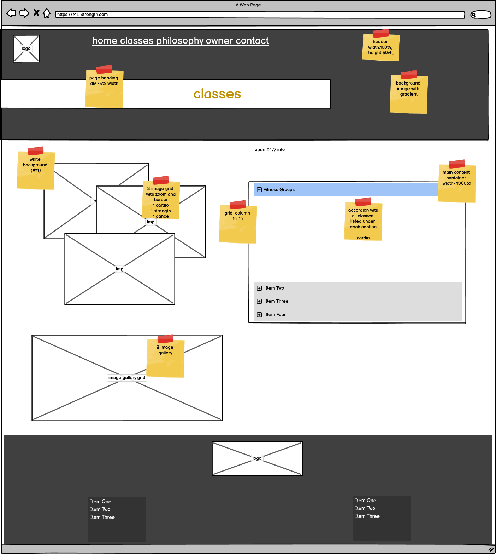

Desktop Classes page

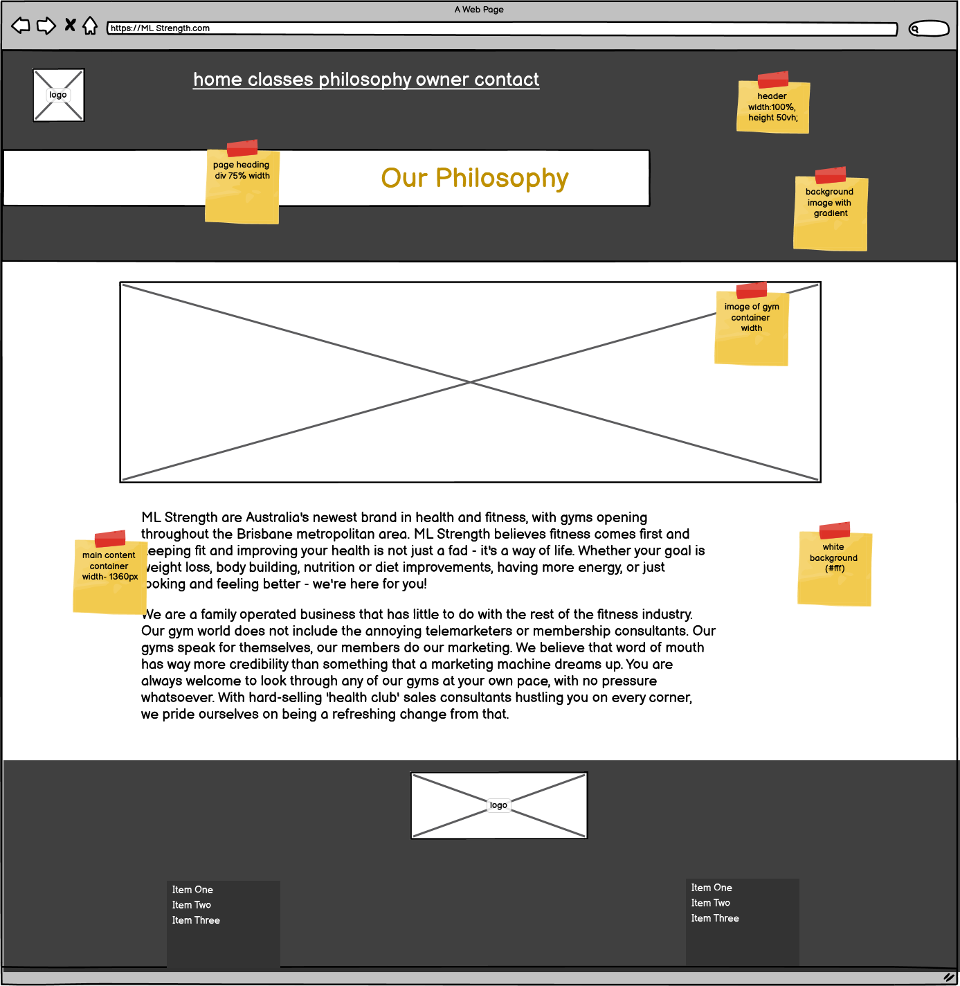

Desktop Philosophy page

Desktop Owner page

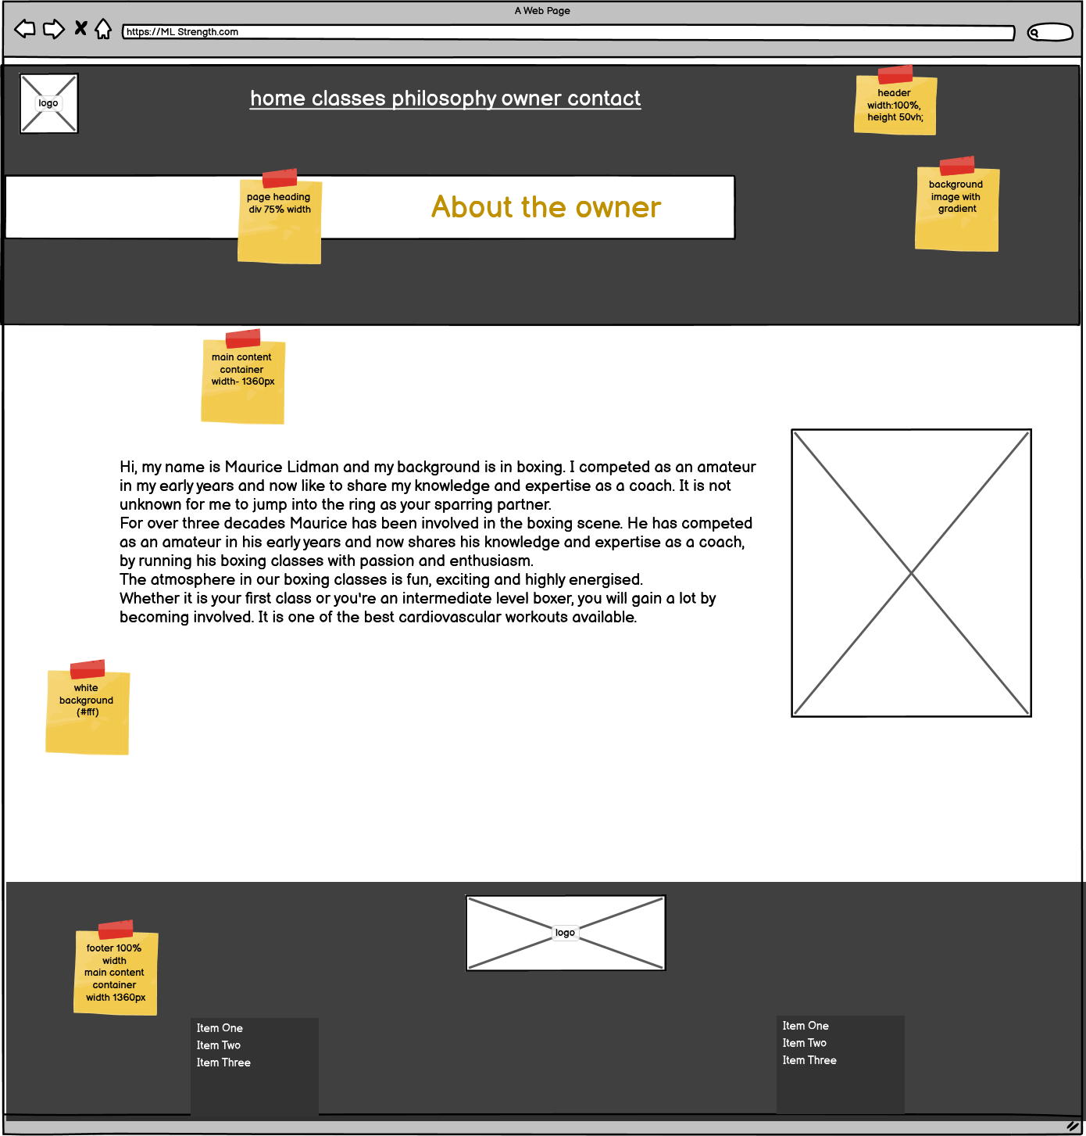

Desktop Contact form page

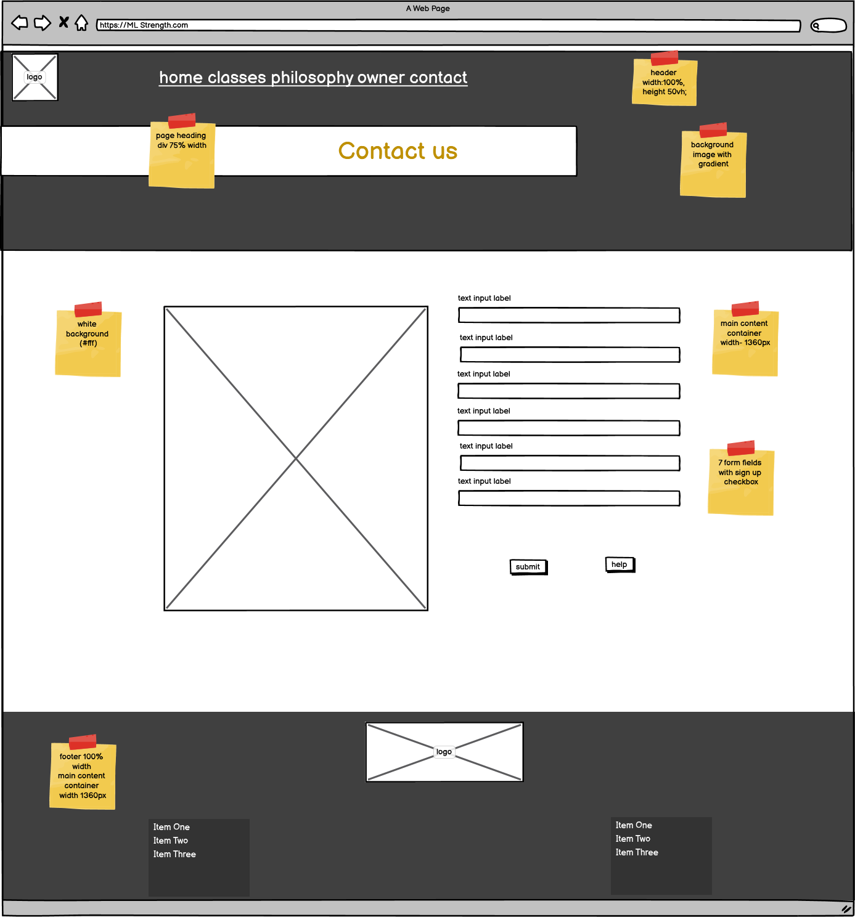

Mobile Index page

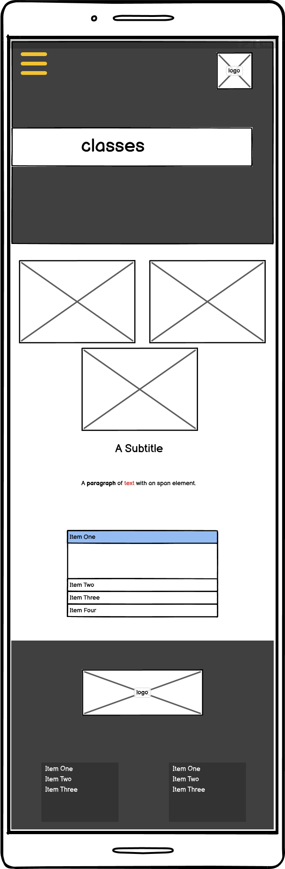

Mobile Classes page

Mobile Philosophy page

Mobile Owner page

Mobile Contact page

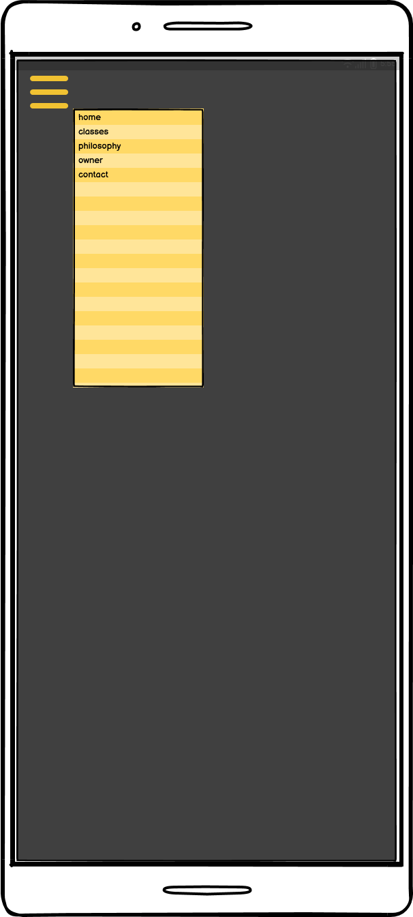

Pop-up Menu page

Styling Information

Typography

|  |  |
| --- | --- |
| Main Styles | |
| Title/Heading 1 | 60px - 40px |
| Heading 2 | 30px |
| Heading 3 | 25px - 30px |
| Heading 4 | 20px - 25px |
| Link: link, active and hover | 20px |
| Paragraph | 20px |
| Fig caption | 18px/14px/12px |
| Unordered Lists | 16px |
| Font-family | |
| Headings | Palanquin Dark |
| Paragraphs/list | Lato |
| Back-up | Sans serif |

Iconography

The iconography format style I chose is from the font-awesome, as they could be added using CSS content,. These can then be coloured using color in CSS, and sized using font-size in CSS.

Below is listed the specific icons I chose and why:

|  |  |
| --- | --- |
|  | To represent the name in the form field |
|  | To represent the email address in the form field |
|  | To represent the phone number in the form field |

Colour Scheme

|  |  |
| --- | --- |
| **COLOUR SCHEMES** | |
| **PAGE CONTENT** | |
| **Background:**  Header background will be a gradient fading from left to right using #212529  Main page background will be white #fff  Footer background will be set using background color to #0a0b0c. | **Text:**  Headings and text will use a dark grey #212529 except the main title headings and text which will use white #fff as they have a dark background |
| **Buttons/Links:**  Buttons will be set using the secondary colour orange #e8590c.  Nav Links will be white #fff as they are set on a black background.  CTA links will use the secondary colour orange #e8590c.  **Icons:**  Form icons will use the secondary colour orange #e8590c. | **FORMS:**  **Background:**  White background with orange border  **Labels:**  Page Text colour  *required as secondary orange colour  **Input fields:**  Grey background  Placeholder slightly darker grey  **Submit Button:**  Secondary orange colour.  Help link grey background with secondary orange text. |
| **SCHEME**  Colour Palette |
| **White space** | Used for main content only |

2. Test, debug and validate (Part 3)

Validation

*Include screenshots of your first round of validation (HTML and CSS) here. Ensure you clearly label the file being validated. If corrections are required you should make the corrections and revalidate and include the updated screenshots.*

Accessibility Testing

*Include screenshots of your first round of accessibility here. If corrections are required you should make the corrections and retest and include the updated screenshots.*

Browser/Device Testing

*Include your screenshots here. You should ensure you clearly label each screenshot with the device and browser used for your testing*

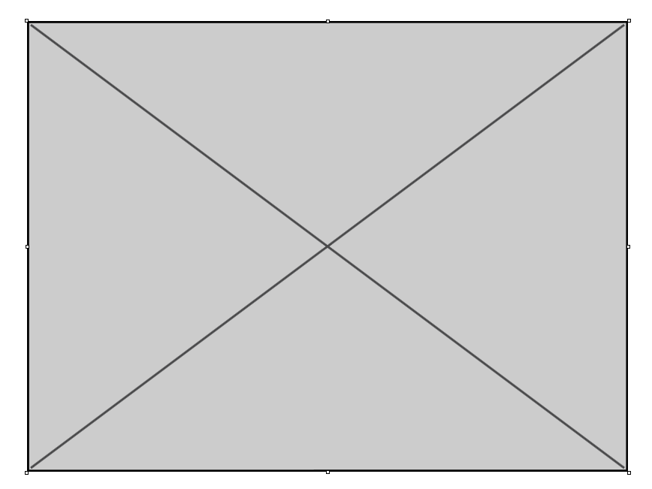

Figure ge - Desktop PC - Google Chrome

Cyber security measures

*Include the answers to the cyber security questions here*

Authentication process

Programmatically engineered solutions to avoid cyber-attacks

Internet protocols

Project Signoff

*Copy, paste and complete the project signoff table from the assessment document*

3. Knowledge Questions (Part 4)

*Include the answers to your knowledge questions here ensuring that you clearly identify each question*

Appendices

*Include any appendices in this section*

References

*Include any references in this section*